SIMATS ENGINEERING
ASSESSMENT TOOL 1
Experiments
STUDENT NAME: SANDHIYA K
Reg.No:192521378
COURSE NAME:Computer Networks | COURSE CODE: | CSA0711

COURSE OUTCOME COVERED
CO3: Analyze the performance of core network protocols such as TCP, UDP, HTTP, and
DNS under varying conditions
Assessment Tool Weightage: 40%
SOFTWARE: CISCO PACKET TRACER, WIRESHARK
EXPERIMENTS
QUESTIONS:4 Total Marks:40
1.Design a simple LAN consisting of two PCs connected through a switch using
Cisco Packet Tracer. Configure appropriate IP addresses for both hosts and verify
connectivity using the ping command. Simultaneously capture the packet
exchange using Wireshark. Identify the Ethernet frame fields such as Source
MAC Address, Destination MAC Address, EtherType, and Frame Check
Sequence (FCS). Explain how the Data Link layer uses MAC addressing to ensure
successful frame delivery within the local network.
2.Create a network topology consisting of two LANs connected through a routerin
Cisco Packet Tracer. Configure IPv4 addressing, subnet masks, and default
gateways for all devices, and verify end-to-end communication using the ping
command. Capture the ICMP packets using Wireshark and analyze the IPv4
header fields, including Source IP Address, Destination IP Address, Time-To-
Live (TTL), Protocol Number, and Header Length. Explain the role of the
Network layer in forwarding packets between different networks.
3.Construct a local area network with multiple hosts connected through a switch in
Cisco Packet Tracer. Clear the ARP cache on one of the hosts and initiate
communication with another host using the ping command. Capture the
communication in Wireshark and identify the ARP Request and ARP Reply
packets. Analyze the sender and target MAC/IP addresses and explain how the
Address Resolution Protocol resolves logical IP addresses into physical MAC
addresses before data transmission.
4.Develop a simple network consisting of two PCs connected through a router in
Cisco Packet Tracer. Configure the required IP addresses and test connectivity
using the ping command. Capture the ICMP traffic using Wireshark and identify
the Echo RequestandEcho Reply messages. Examine important ICMP fields
such as Type, Code, Identifier, and Sequence Number, and calculate the Round

Trip Time (RTT). Discuss how ICMP assists in network troubleshooting and
connectivity verification.
5.Create a client-server network in Cisco Packet Tracer by configuring a web server
and a client PC. Enable the HTTP service on the server and access the hosted
webpage from the client using a web browser. Capture the communication in
Wireshark and identify the TCP three-way handshake, followed by the HTTP
GET request and HTTP response messages. Analyze the application-layer
communication and explain how TCP provides reliable delivery for HTTP traffic
through connection establishment, acknowledgments, and ordered data transfer.
RUBRICS FOR CALCULATION
Criteria | Weightag  e | Level 4 –  Exemplary | Level 3 –  Proficient | Level 2 –  Developing | Level 1 –  Beginning
Understandin  g of Concepts | 25 | Demonstrates  thorough  understanding and effectively  integrates multiple concepts/technologi es | Good  understanding  with proper  integration of most  concepts | Basic  understanding  ; limited or  partial  integration | Poor  understanding  ; unable to  integrate  concepts
Experimental  Design | 30 | Well-planned,  systematic  implementation  with optimal  solution | Correct  implementati  on with minor  issues | Basic  implementati  on with errors or  inefficiencies | Incorrect or  incomplete  implementati  on
Use of Tools | 20 | Effective and  advanced use of  tools/technologies with proper  configuration | Appropriate  use of tools  with correct  execution | Limited or  inconsistent  use of tools | Incorrect or  minimal use  of tools
Analysis of  Results | 15 | Insightful analysis with accurate  interpretation and validation of results | Good  analysis with  reasonable  interpretation | Basic  analysis with  limited  insights | Poor or  incorrect  analysis of  results
Documentati  on | 10 | Clear, well-  structured  documentation with diagrams, code, and results | Organized  documentatio  n with  necessary  details | Basic  documentatio  n with  missing  details | Poor or  incomplete  documentatio  n

Experiment 1: LAN Communication and
Ethernet Frame Analysis
Aim
To design a simple LAN using two PCs and a switch, configure IP addresses, verify connectivity
using the ping command, and analyze Ethernet frame fields using Wireshark.
Software Required
●Cisco Packet Tracer
●Wireshark
Procedure
1.Open Cisco Packet Tracer.
2.Place one switch and two PCs.
3.Connect both PCs to the switch using Copper Straight-Through cables.
4.Configure the IP addresses:
○ PC0: 192.168.1.10 /24
○ PC1: 192.168.1.20 /24
5.Open the Command Prompt on PC0.
6.Run the command:
ping 192.168.1.20
7.Start Wireshark and capture the packets.
8.Observe the Ethernet frame fields such as Source MAC, Destination MAC, EtherType,
and FCS.
Input
●IP Address (PC0): 192.168.1.10
●IP Address (PC1): 192.168.1.20
●Ping Command:
ping 192.168.1.20

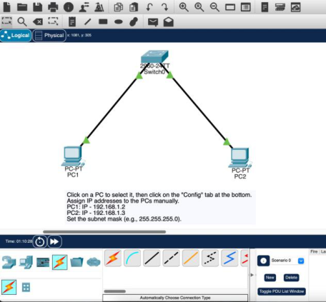

Output
●Ping reply received successfully.
●Wireshark captured Ethernet frames showing:
○Source MAC Address
○Destination MAC Address
○EtherType (IPv4)
○Frame Check Sequence (FCS)
Result
The LAN was successfully created, communication between the two PCs was verified using the
ping command, and the Ethernet frame fields were analyzed in Wireshark.
Experiment 2: Communication Between Two
LANs Through a Router
Aim
To connect two LANs through a router, configure IPv4 addressing, and analyze IPv4 header
fields using Wireshark.
Software Required
●Cisco Packet Tracer
●Wireshark
Procedure
1.Create two LANs with a router between them.
2.Configure the following IP addresses:
○ PC0: 192.168.1.10/24
○ Router G0/0: 192.168.1.1/24
○ Router G0/1: 192.168.2.1/24
○ PC1: 192.168.2.10/24
3.Set the default gateways on both PCs.
4.Open the Command Prompt on PC0.

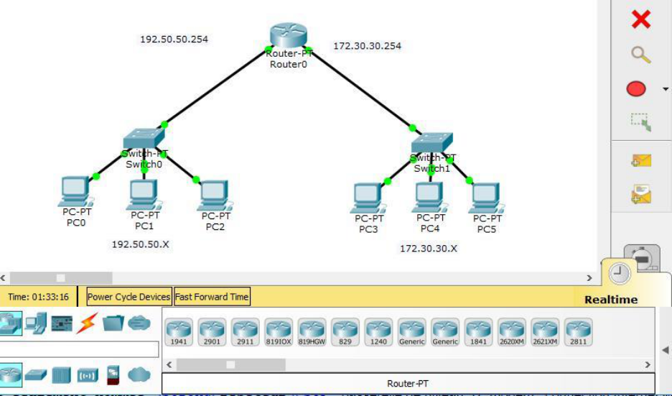

5.Run:
ping 192.168.2.10
6.Capture packets using Wireshark.
7.Analyze Source IP, Destination IP, TTL, Protocol Number, and Header Length.
Input
●Source IP: 192.168.1.10
●Destination IP: 192.168.2.10
●Ping Command:
ping 192.168.2.10
Output
●Successful ping response.
●IPv4 packet captured showing:
○Source IP Address
○Destination IP Address
○TTL
○Protocol Number (ICMP)
○Header Length
Result
Communication between two different LANs was established successfully, and the IPv4 header
fields were analyzed using Wireshark.
Experiment 3: ARP Protocol Analysis
Aim

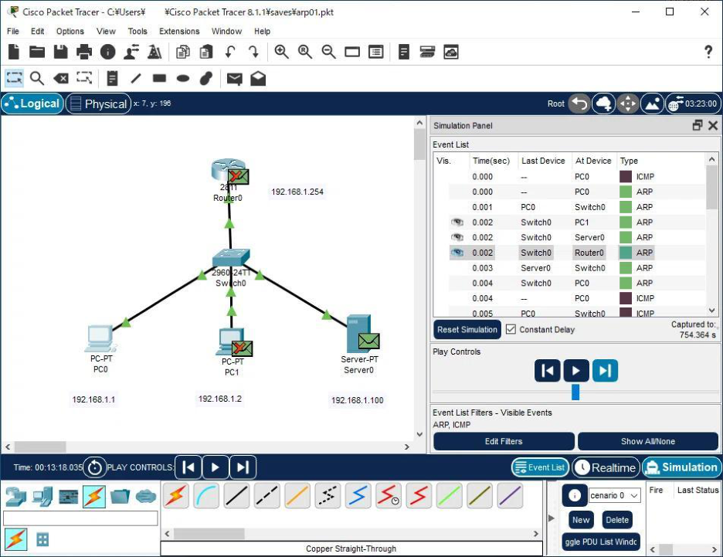

To study the Address Resolution Protocol (ARP) by capturing ARP Request and ARP Reply
packets using Wireshark.
Software Required
●Cisco Packet Tracer
●Wireshark
Procedure
1.Connect two PCs through a switch.
2.Configure IP addresses:
○ PC0: 192.168.1.10
○ PC1: 192.168.1.20
3.Clear the ARP cache.
4.Start Wireshark.
5.Ping PC1 from PC0.
6.Observe the ARP Request and ARP Reply packets.
Input
●Ping Command:
ping 192.168.1.20
Output
●ARP Request packet captured.
●ARP Reply packet captured.
●Sender and Target IP/MAC addresses displayed.

Result
ARP successfully resolved the destination IP address into a MAC address before
communication.
Experiment 4: ICMP Protocol Analysis
Aim
To configure two PCs connected through a router, test communication, and analyze ICMP Echo
Request and Echo Reply packets.
Software Required
●Cisco Packet Tracer
●Wireshark
Procedure
1.Connect two PCs using a router.
2.Configure the IP addresses.
3.Configure the router interfaces.
4.Open the Command Prompt on PC0.
5.Execute:
ping 192.168.2.10
6.Capture ICMP packets using Wireshark.
7.Observe ICMP Type, Code, Identifier, Sequence Number, and RTT.
Input
●Ping Command:
ping 192.168.2.10

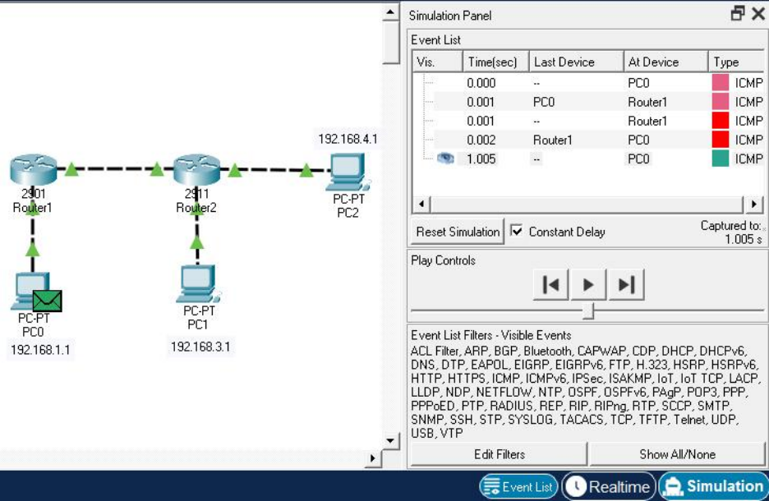

Output
●ICMP Echo Request captured.
●ICMP Echo Reply captured.
●Round Trip Time (RTT) displayed.
Result
ICMP packets were successfully exchanged, verifying network connectivity and enabling
network troubleshooting.
Experiment 5: HTTP Communication Using
TCP
Aim
To configure a client-server network, enable the HTTP service, access a web page, and analyze
TCP and HTTP communication using Wireshark.
Software Required
●Cisco Packet Tracer
●Wireshark
Procedure
1.Place one PC and one Server in Cisco Packet Tracer.
2.Connect them through a switch.
3.Configure IP addresses:
○ Client: 192.168.1.10
○ Server: 192.168.1.20
4.Enable the HTTP service on the server.
5.Open the Web Browser on the client.

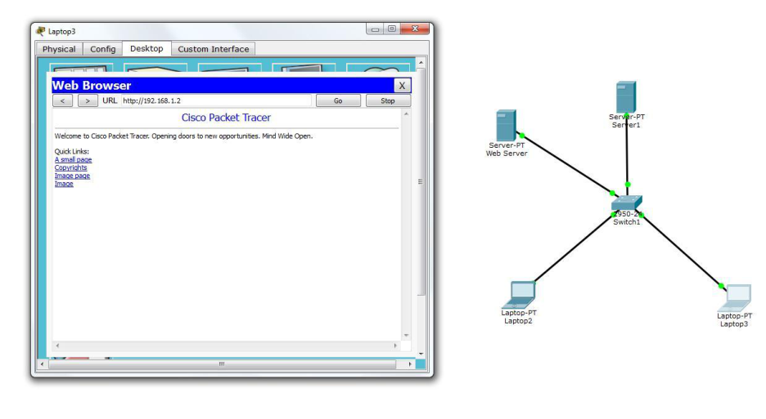

6.Enter:
http://192.168.1.20
7.Capture packets using Wireshark.
8.Observe the TCP three-way handshake and HTTP GET/Response messages.
Input
●URL:
http://192.168.1.20
Output
●Web page displayed successfully.
●Wireshark captured:
○TCP SYN
○SYN-ACK
○ACK
○HTTP GET Request
○HTTP Response (200 OK)
Result
The client successfully accessed the web server, and TCP connection establishment along with
HTTP communication was analyzed using Wireshark.

